1. 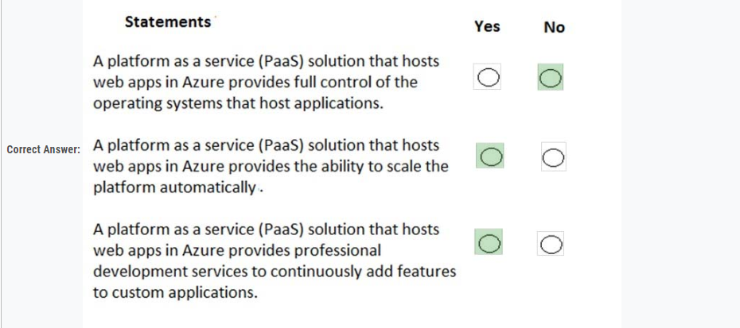
2. 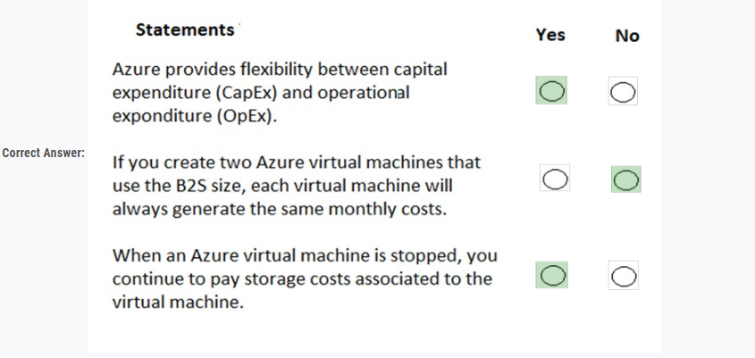
3. When you are implementing a software as a service (SaaS) solution, you are responsible for configuring high availability.  
   Instructions: Review the underlined text. If it makes the statement correct, select "No change is needed". If the statement is incorrect, select the answer choice that makes the statement correct.

A. No change is needed.

B. defining scalability rules

C. installing the SaaS solution

D. configuring the SaaS solution

4. You plan to migrate all the servers to Azure.  
You need to recommend a solution to ensure that some of the servers are available if a single Azure data center goes offline for an extended period.  
What should you include in the recommendation?

* A. fault tolerance
* B. elasticity
* C. scalability
* D. low latency

5.This question requires that you evaluate the underlined text to determine if it is correct.  
An organization that hosts its infrastructure in a private cloud can decommission its data center.

* A. No change is needed.
* B. in a hybrid cloud
* C. in the public cloud
* D. on a Hyper-V host

6. What are two characteristics of the public cloud? Each correct answer presents a complete solution.

* A. dedicated hardware
* B. unsecured connections
* C. limited storage
* D. metered pricing
* E. self-service management

7. When planning to migrate a public website to Azure, you must plan to pay monthly usage costs.

* A. No change is needed
* B. Deploy a VPN
* C. pay to transfer all the website data to Azure
* D. reduce the number of connections to the website

**8.** Your company plans to migrate all its data and resources to Azure.  
The company's migration plan states that only platform as a service (PaaS) solutions must be used in Azure.  
You need to deploy an Azure environment that supports the planned migration.  
Solution: You create an Azure App Service and Azure SQL databases.  
Does this meet the goal?

* A. Yes
* B. No

**9.** Your company hosts an accounting named App1 that is used by all the customers of the company.  
App1 has low usage during the first three weeks of each month and very high usage during the last week of each month.  
Which benefit of Azure Cloud Services supports cost management for this type of usage pattern?

* A. high availability
* B. high latency
* C. elasticity
* D. load balancing

**10.** You plan to migrate a web application to Azure. The web application is accessed by external users.  
You need to recommend a cloud deployment solution to minimize the amount of administrative effort used to manage the web application.  
What should you include in the recommendation?

* A. software as a service (SaaS)
* B. platform as a service (PaaS)
* C. infrastructure as a service (IaaS)
* D. database as a service (DaaS)

**11.** Which cloud deployment solution is used for Azure virtual machines and Azure SQL databases? To answer, select the appropriate options in the answer area.

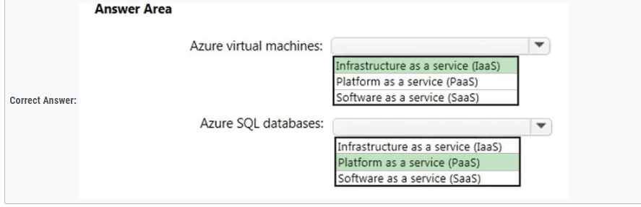

12. You have an on-premises network that contains 100 servers.  
You need to recommend a solution that provides additional resources to your users. The solution must minimize capital and operational expenditure costs.  
What should you include in the recommendation?

* A. a complete migration to the public cloud
* B. an additional data center
* C. a private cloud
* D. a hybrid cloud

13. 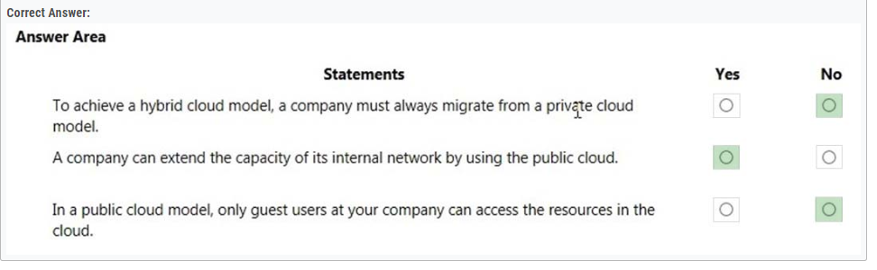

14. You plan to migrate several servers from an on-premises network to Azure.  
You need to identify the primary benefit of using a public cloud service for the servers.  
What should you identify?

* A. The public cloud is owned by the public, NOT a private corporation
* B. The public cloud is a crowd-sourcing solution that provides corporations with the ability to enhance the cloud
* C. All public cloud resources can be freely accessed by every member of the public
* D. The public cloud is a shared entity whereby multiple corporations each use a portion of the resources in the cloud

15. You plan to deploy several Azure virtual machines.  
You need to ensure that the services running on the virtual machines are available if a single data center fails.  
Solution: You deploy the virtual machines to two or more availability zones.

Does this meet the goal?

* A. Yes
* B. No

16. You have 1,000 virtual machines hosted on the Hyper-V hosts in a data center.  
You plan to migrate all the virtual machines to an Azure pay-as-you-go subscription.  
You need to identify which expenditure model to use for the planned Azure solution.  
Which expenditure model should you identify?

* A. operational
* B. elastic
* C. capital
* D. scalable

17. 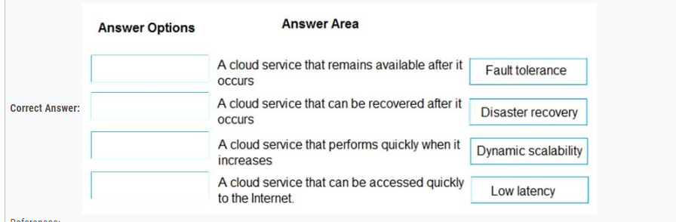

18. 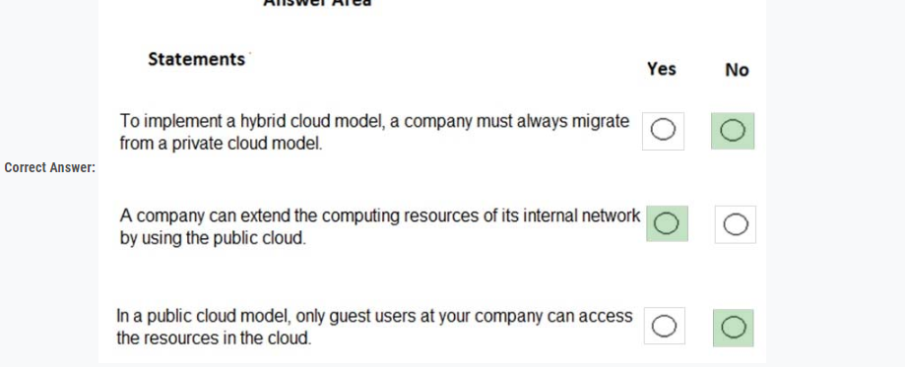

19. 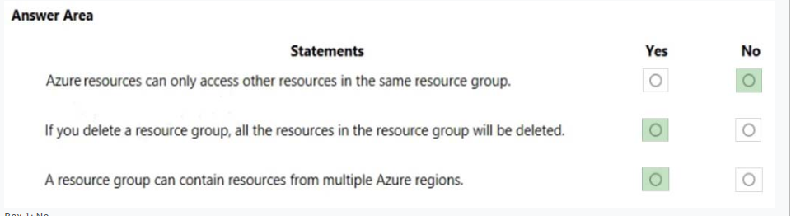

20. The company plans to reduce the following administrative responsibilities of network administrators:  
✑ Backing up application data  
✑ Replacing failed server hardware  
✑ Managing physical server security  
✑ Updating server operating systems  
✑ Managing permissions to shared documents  
The company plans to migrate several servers to Azure virtual machines.  
You need to identify which administrative responsibilities will be reduced after the planned migration.  
Which two responsibilities should you identify? Each correct answer presents a complete solution.

* A. Replacing failed server hardware
* B. Backing up application data
* C. Managing physical server security
* D. Updating server operating systems
* E. Managing permissions to shared documents

21. 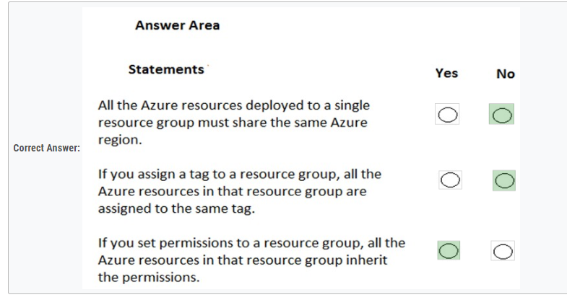

22. Your company plans to deploy an Artificial Intelligence (AI) solution in Azure.  
What should the company use to build, test, and deploy predictive analytics solutions?

* A. Azure Logic Apps
* B. Azure Machine Learning Studio
* C. Azure Batch
* D. Azure Cosmos DB

23. 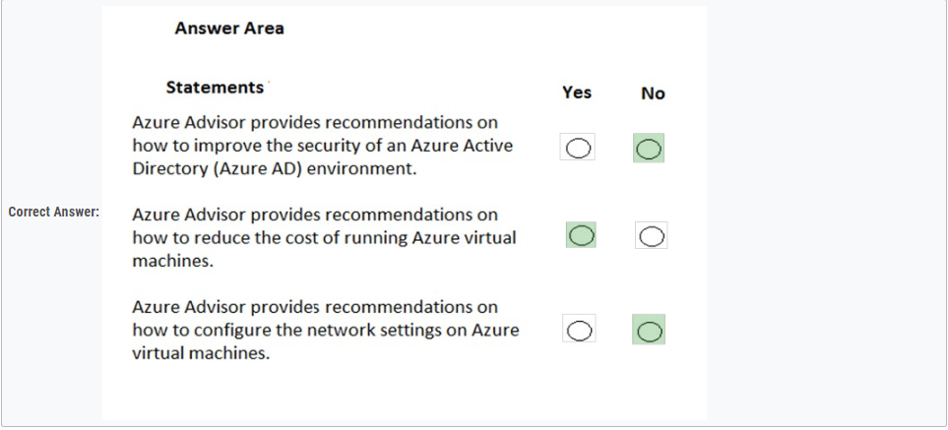

24. Several support engineers plan to manage Azure by using the computers shown in the following table:  
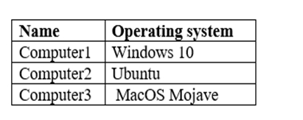  
You need to identify which Azure management tools can be used from each computer.  
What should you identify for each computer? To answer, select the appropriate options in the answer area.

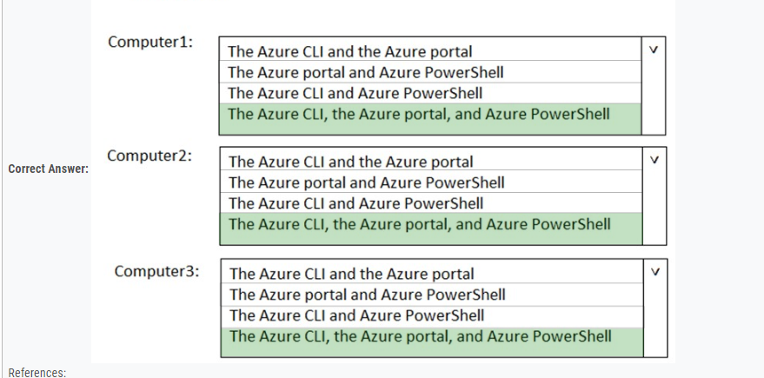

25. Azure policies provide a common platform for deploying objects to a cloud infrastructure and for implementing consistency across the Azure environment.

* A. No change is needed
* B. Resource groups provide
* C. Azure Resource Manager provides
* D. Management groups provide

26. 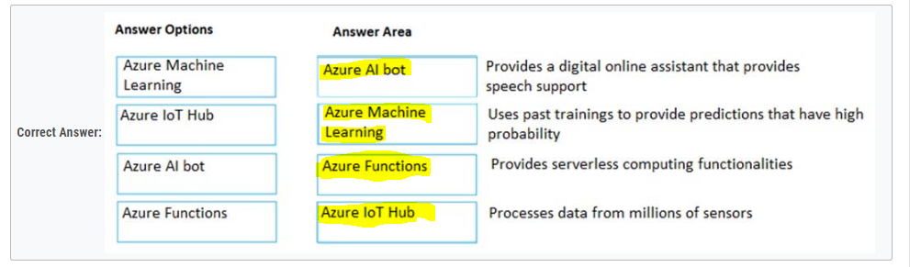

27. Each business unit requires 20 different Azure resources for daily operation. All the business units require the same type of Azure resources.  
You need to recommend a solution to automate the creation of the Azure resources.  
What should you include in the recommendations?

* A. Azure Resource Manager templates
* B. virtual machine scale sets
* C. the Azure API Management service
* D. management groups

28. 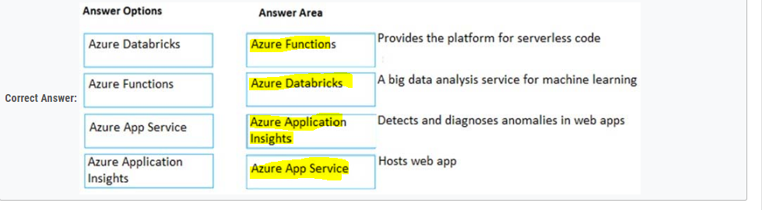

29. You plan to deploy a critical line-of-business application to Azure.  
The application will run on an Azure virtual machine.  
You need to recommend a deployment solution for the application. The solution must provide a guaranteed availability of 99.99 percent.  
What is the minimum number of virtual machines and the minimum number of availability zones you should recommend for the deployment? To answer, select the appropriate options in the answer area.

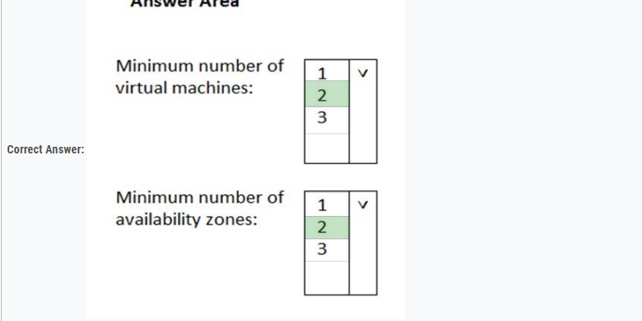

30. Which Azure service should you use to correlate events from multiple resources into a centralized repository?

* A. Azure Event Hubs
* B. Azure Analysis Services
* C. Azure Monitor
* D. Azure Log Analytics

31. You have an Azure environment. You need to create a new Azure virtual machine from an Android laptop.  
Solution: You use PowerShell in Azure Cloud Shell.  
Does this meet the goal?

* A. Yes
* B. No

32. You have an Azure environment. You need to create a new Azure virtual machine from an Android laptop.  
Solution: You use the Azure portal.  
Does this meet the goal?

* A. Yes
* B. No

33. 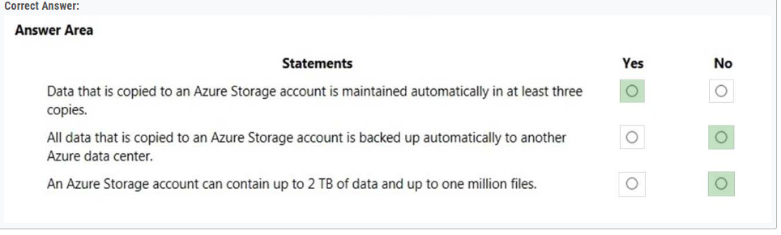

34. 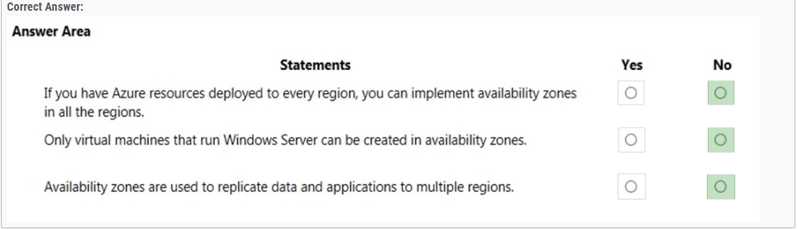

35. An Azure region contains one or more data centers that are connected by using a low-latency network.  
Instructions: Review the underlined text. If it makes the statement correct, select "No change is needed". If the statement is incorrect, select the answer choice that makes the statement correct.

* A. No change is needed
* B. Is found in each country where Microsoft has a subsidiary office
* C. Can be found in every country in Europe and the Americas only
* D. Contains one or more data centers that are connect by using a high-latency network

36. You plan to deploy 20 virtual machines to an Azure environment. To ensure that a virtual machine named VM1 cannot connect to the other virtual machines, VM1 must be deployed to a separate virtual network.  
Instructions: Review the underlined text. If it makes the statement correct, select "No change is needed". If the statement is incorrect, select the answer choice that makes the statement correct.

* A. No change is needed
* B. run a different operating system than the other virtual machines
* C. be deployed to a separate resource group
* D. have two network interfaces

37. When you need to delegate permissions to several Azure virtual machines simultaneously, you must deploy the Azure virtual machines to the same Azure region.  
Instructions: Review the underlined text. If it makes the statement correct, select "No change is needed". If the statement is incorrect, select the answer choice that makes the statement correct.

* A. No change is needed
* B. by using the same Azure Resource Manager template
* C. to the same resource group
* D. to the same availability zone

38. A team of developers at your company plans to deploy, and then remove, 50 customized virtual machines each week. Thirty of the virtual machines run Windows  
Server 2016 and 20 of the virtual machines run Ubuntu Linux.  
You need to recommend which Azure service will minimize the administrative effort required to deploy and remove the virtual machines.  
What should you recommend?

* A. Azure Reserved Virtual Machines (VM) Instances
* B. Azure virtual machine scale sets
* C. Azure DevTest Labs
* D. Microsoft Managed Desktop

39. One of the benefits of Azure SQL Data Warehouse is that high availability is built into the platform.  
Instructions: Review the underlined text. If it makes the statement correct, select "No change is needed". If the statement is incorrect, select the answer choice that makes the statement correct.

* A. No change is needed
* B. automatic scaling
* C. data compression
* D. versioning

40. A support engineer plans to perform several Azure management tasks by using the Azure CLI.  
You install the CLI on a computer.  
You need to tell the support engineer which tools to use to run the CLI.  
Which two tools should you instruct the support engineer to use? Each correct answer presents a complete solution.  
NOTE: Each correct selection is worth one point.

* A. Command Prompt
* B. Azure Resource Explorer
* C. Windows PowerShell
* D. Windows Defender Firewall
* E. Network and Sharing Center

41. You need to manage Azure by using Azure Cloud Shell.  
Which Azure portal icon should you select? To answer, select the appropriate icon in the answer area.

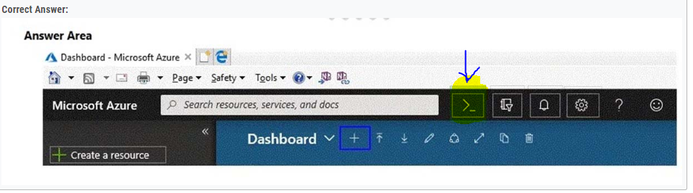

42. You plan to store 20 TB of data in Azure. The data will be accessed infrequently and visualized by using Microsoft Power BI.  
You need to recommend a storage solution for the data.  
Which two solutions should you recommend? Each correct answer presents a complete solution.  
NOTE: Each correct selection is worth one point.

* A. Azure Data Lake
* B. Azure Cosmos DB
* C. Azure SQL Data Warehouse
* D. Azure SQL Database
* E. Azure Database for PostgreSQL

43. You have an Azure environment that contains 10 web apps. To which URL should you connect to manage all the Azure resources? To answer, select the appropriate options in the answer area.

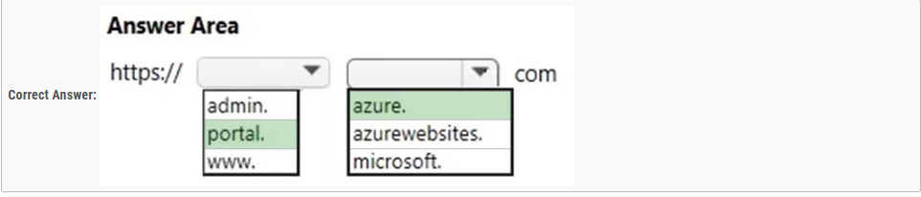

44. You need to identify the type of failure for which an Azure availability zone can be used to protect access to Azure services.  
What should you identify?

* A. a physical server failure
* B. an Azure region failure
* C. a storage failure
* D. an Azure data center failure

45. You plan to extend your company's network to Azure. The network contains a VPN appliance that uses an IP address of 131.107.200.1.  
You need to create an Azure resource that identifies the VPN appliance.  
Which Azure resource should you create? To answer, select the appropriate resource in the answer area.

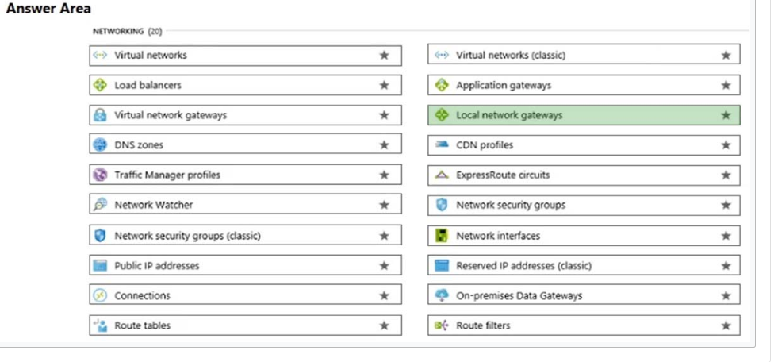

46. You have a virtual machine named VM1 that runs Windows Server 2016. VM1 is in the East US Azure region.  
Which Azure service should you use from the Azure portal to view service failure notifications that can affect the availability of VM1?

* A. Azure Service Fabric
* B. Azure Monitor
* C. Azure virtual machines
* D. Azure Advisor

47. An Azure administrator plans to run a PowerShell script that creates Azure resources.  
You need to recommend which computer configuration to use to run the script.  
Solution: Run the script from a computer that runs macOS and has PowerShell Core 6.0 installed.  
Does this meet the goal?

* A. Yes
* B. No

48. You have an Azure environment that contains 10 virtual networks and 100 virtual machines.  
You need to limit the amount of inbound traffic to all the Azure virtual networks.  
What should you create?

* A. one network security group (NSG)
* B. 10 virtual network gateways
* C. 10 Azure ExpressRoute circuits
* D. one Azure firewall

49.you need to view a list of planned maintenance events that can affect the availability of an Azure subscription.  
Which blade should you use from the Azure portal?



50. Match the Azure service to the correct definition.  
Instructions: To answer, drag the appropriate Azure service from the column on the left to its description on the right. Each service may be used once, more than once, or not at all.  
NOTE: Each correct match is worth one point.  
Select and Place:

An integrated solution for the deployment of code - Azure DevOps

A tool that provides guidance and recommendation to improve an Azure environment - Azure Advisor

A simplified tool to build intelligent Artificial Intelligence (AI) applications - Azure Cognitive services Monitors web applications - Azure Application Insights

51. ou have an Azure environment that contains multiple Azure virtual machines.  
You plan to implement a solution that enables the client computers on your on-premises network to communicate to the Azure virtual machines.  
You need to recommend which Azure resources must be created for the planned solution.  
Which two Azure resources should you include in the recommendation? Each correct answer presents part of the solution.  
NOTE: Each correct selection is worth one point.

* A. a virtual network gateway
* B. a load balancer
* C. an application gateway
* D. a virtual network
* E. a gateway subnet

52.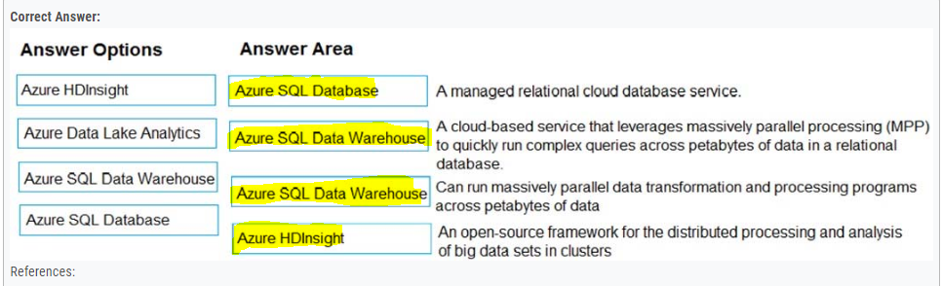

53. You need to identify which blades in the Azure portal must be used to perform the following tasks:  
✑ View security recommendations.  
✑ Monitor the health of Azure services.  
✑ Browse available virtual machine images.  
Which blade should you identify for each task? To answer, select the appropriate options in the answer area.  
NOTE: Each correct selection is worth one point.

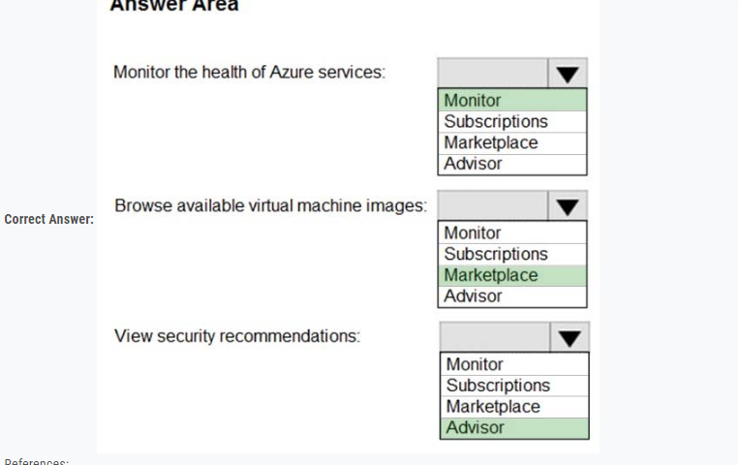

54. You plan to create an Azure virtual machine.  
You need to identify which storage service must be used to store the data disks of the virtual machine.  
What should you identify? To answer, select the appropriate service in the answer area.

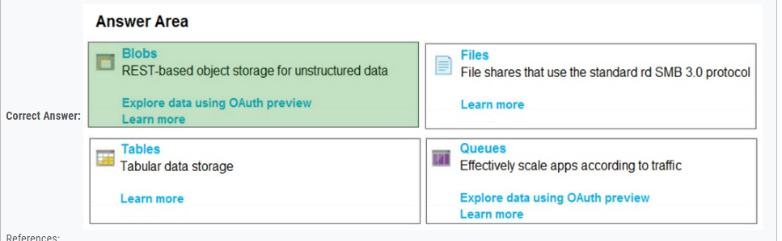

55. Your company plans to move several servers to Azure.  
The company's compliance policy states that a server named FinServer must be on a separate network segment.  
You are evaluating which Azure services can be used to meet the compliance policy requirements.  
Which Azure solution should you recommend?

* A. a resource group for FinServer and another resource group for all the other servers
* B. a virtual network for FinServer and another virtual network for all the other servers
* C. a VPN for FinServer and a virtual network gateway for each other server
* D. one resource group for all the servers and a resource lock for FinServer

56. You plan to map a network drive from several computers that run Windows 10 to Azure Storage. You need to create a storage solution in Azure for the planned mapped drive.  
What should you create?

* A. an Azure SQL database
* B. a virtual machine data disk
* C. a Files service in a storage account
* D. a Blobs service in a storage account

57. You plan to implement an Azure database solution.  
You need to implement a database solution that meets the following requirements:  
✑ Can add data concurrently from multiple regions  
✑ Can store JSON documents  
Which database service should you deploy? To answer, select the appropriate service in the answer area.



58. Your company plans to migrate all its network resources to Azure.  
You need to start the planning process by exploring Azure.  
What should you create first?

* A. a subscription
* B. a resource group
* C. a virtual network
* D. a management group

59. You have an on-premises application that sends email notifications automatically based on a rule.  
You plan to migrate the application to Azure.  
You need to recommend a serverless computing solution for the application.  
What should you include in the recommendation?

* A. a web app
* B. a server image in Azure Marketplace
* C. a logic app
* D. an API app

60. You plan to deploy a website to Azure. The website will be accessed by users worldwide and will host large video files.  
You need to recommend which Azure feature must be used to provide the best video playback experience.  
What should you recommend?

* A. an application gateway
* B. an Azure ExpressRoute circuit
* C. a content delivery network (CDN)
* D. an Azure Traffic Manager profile

61. Your company plans to deploy several million sensors that will upload data to Azure.  
You need to identify which Azure resources must be created to support the planned solution.  
Which two Azure resources should you identify? Each correct answer presents part of the solution.  
NOTE: Each correct selection is worth one point.

* A. Azure Data Lake
* B. Azure Queue storage
* C. Azure File Storage
* D. Azure IoT Hub
* E. Azure Notification Hubs

62. You have an Azure web app.  
You need to manage the settings of the web app from an iPhone.  
What are two Azure management tools that you can use? Each correct answer presents a complete solution.  
NOTE: Each correct selection is worth one point.

* A. Azure CLI
* B. the Azure portal
* C. Azure Cloud Shell
* D. Windows PowerShell
* E. Azure Storage Explorer

63. This question requires that you evaluate the underlined text to determine if it is correct.  
You have an application that is comprised of an Azure web app that has a Service Level Agreement (SLA) of 99.95 percent and an Azure SQL database that has an SLA of 99.99 percent.  
The composite SLA for the application is the product of both SLAs, which equals 99.94 percent.  
Instructions: Review the underlined text. If it makes the statement correct, select "No change is needed". If the statement is incorrect, select the answer choice that makes the statement correct.

* A. No change is needed
* B. the lowest SLA associated to the application, which is 99.95 percent
* C. the highest SLA associated to the application, which is 99.99 percent
* D. the difference between the two SLAs, which is 0.05 percent

64. This question requires that you evaluate the underlined text to determine if it is correct.  
If a resource group named RG1 has a delete lock, only a member of the global administrators group can delete RG1.  
Instructions: Review the underlined text. If it makes the statement correct, select "No change is needed". If the statement is incorrect, select the answer choice that makes the statement correct.

* A. No change is needed
* B. the delete lock must be removed before an administrator
* C. an Azure policy must be modified before an administrator
* D. an Azure tag must be added before an administrator

65. This question requires that you evaluate the underlined text to determine if it is correct.  
Azure Germany can be used by legal residents of Germany only.  
Instructions: Review the underlined text. If it makes the statement correct, select "No change is needed". If the statement is incorrect, select the answer choice that makes the statement correct.

* A. no change is needed
* B. only enterprises that are registered in Germany
* C. only enterprises that purchase their azure licenses from a partner based in Germany
* D. any user or enterprise that requires its data to reside in Germany

66. This question requires that you evaluate the underlined text to determine if it is correct.  
After you create a virtual machine, you need to modify the network security group (NSG) to allow connections from TCP port 8080 to the virtual machine.  
Instructions: Review the underlined text. If it makes the statement correct, select "No change is needed". If the statement is incorrect, select the answer choice that makes the statement correct.

* A. No change is needed
* B. virtual network gateway
* C. virtual network
* D. route table

67. Note: This question is part of a series of questions that present the same scenario. Each question in the series contains a unique solution that might meet the stated goals. Some question sets might have more than one correct solution, while others might not have a correct solution.  
After you answer a question in this section, you will NOT be able to return to it. As a result, these questions will not appear in the review screen.  
Your Azure environment contains multiple Azure virtual machines.  
You need to ensure that a virtual machine named VM1 is accessible from the Internet over HTTP.  
Solution: You modify an Azure firewall.  
Does this meet the goal?

* A. Yes
* B. No

68. Which two types of customers are eligible to use Azure Government to develop a cloud solution? Each correct answer presents a complete solution.  
NOTE: Each correct selection is worth one point.

* A. a Canadian government contractor
* B. a European government contractor
* C. a United States government entity
* D. a United States government contractor
* E. a European government entity

69. For each of the following statements, select Yes if the statement is true. Otherwise, select No.  
NOTE: Each correct selection is worth one point.

To implement an Azure Multi-Factor Authentication(MFA) solution, you must deploy a federation solution or sync on-premises identities to the cloud-->NO,

Two valid methods for Azure Multi-Factor Authentication (MFA) are picture identification and a passport number-->NO,

Azure Multi-Factor Authentication (MFA) can be required for administrative and non-administrative user accounts--> YES

70. You need to ensure that when Azure Active Directory (Azure AD) users connect to Azure AD from the Internet by using an anonymous IP address, the users are prompted automatically to change their password.  
Which Azure service should you use?

* A. Azure AD Connect Health
* B. Azure AD Privileged Identity Management
* C. Azure Advanced Threat Protection (ATP)
* D. Azure AD Identity Protection

71. Q/A Identify and deliver electronic information that can be used as evidence in legal cases - eDiscovery Control how a Microsoft support engineer accesses your data during a help session - Customer Lockbox Extend an existing telephone system for call delegation and call on-behalf functionality - PSTN Calling Provide statistics that help you understand how you spend your time at work – MyAnalitics

72. **An organization that defines all international standards across all industries –ISO

*An organization that defines the standards used by the US govt –NIST

*An European policy that defines data privacy & protection- GDPR

*A dedicated public cloud for federal/state agencies in the US- Azure Government

73. Your company plans to deploy several web servers and several database servers to Azure.  
You need to recommend an Azure solution to limit the types of connections from the web servers to the database servers.  
What should you include in the recommendation?

* A. network security groups (NSGs)
* B. Azure Service Bus
* C. a local network gateway
* D. a route filter

74. To what should an application connect to retrieve security tokens?

* A. an Azure Storage account
* B. Azure Active Directory (Azure AD)
* C. a certificate store
* D. an Azure key vault

75. This question requires that you evaluate the underlined text to determine if it is correct.  
Resource groups provide organizations with the ability to manage the compliance of Azure resources across multiple subscriptions.  
Instructions: Review the underlined text. If it makes the statement correct, select "No change is needed". If the statement is incorrect, select the answer choice that makes the statement correct.

* A. No change is needed
* B. Management groups
* C. Azure policies
* D. Azure App Service plans

76. Your network contains an Active Directory forest. The forest contains 5,000 user accounts.  
Your company plans to migrate all network resources to Azure and to decommission the on-premises data center.  
You need to recommend a solution to minimize the impact on users after the planned migration.  
What should you recommend?

* A. Implement Azure Multi-Factor Authentication (MFA)
* B. Sync all the Active Directory user accounts to Azure Active Directory (Azure AD)
* C. Instruct all users to change their password
* D. Create a guest user account in Azure Active Directory (Azure AD) for each user

77. You create a resource group named RG1 in Azure Resource Manager.  
You need to prevent the deletion of the resources in RG1.  
Which setting should you use? To answer, select the appropriate setting in the answer area.

1 No change is needed. 2 The delete lock must be removed before an administrator. 3 An Azure policy must be modified before an administrator. 4 An Azure tag must be added before an administrator. I think the correct answer is The delete lock must be removed before an administrator.

78. Which Azure service should you use to store certificates?

* A. Azure Security Center
* B. an Azure Storage account
* C. Azure Key Vault
* D. Azure Information Protection

79. You have a resource group named RG1.  
You plan to create virtual networks and app services in RG1.  
You need to prevent the creation of virtual machines only in RG1.  
What should you use?

* A. a lock
* B. an Azure role
* C. a tag
* D. an Azure policy

80.What can Azure Information Protection encrypt?

* A. network traffic
* B. documents and email messages
* C. an Azure Storage account
* D. an Azure SQL database

81. What should you use to evaluate whether your company's Azure environment meets regulatory requirements?

* A. the Knowledge Center website
* B. the Advisor blade from the Azure portal
* C. Compliance Manager from the Security Trust Portal
* D. the Security Center blade from the Azure portal

82.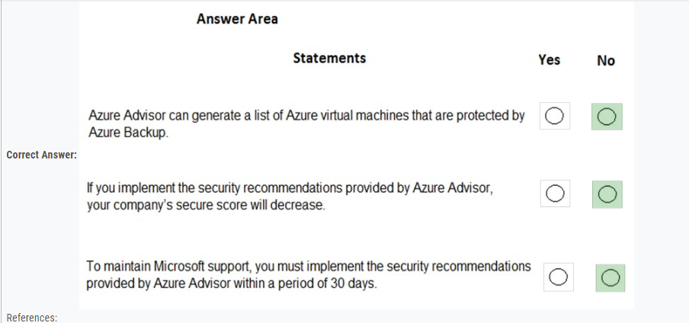

83. This question requires that you evaluate the underlined text to determine if it is correct.  
Your company implements Azure policies to automatically add a watermark to Microsoft Word documents that contain credit card information.  
Instructions: Review the underlined text. If it makes the statement correct, select "No change is needed". If the statement is incorrect, select the answer choice that makes the statement correct.

* A. No change is needed.
* B. DDoS protection
* C. Azure Information Protection
* D. Azure Active Directory (Azure AD) Identity Protection

84. This question requires that you evaluate the underlined text to determine if it is correct.  
From Azure Monitor, you can view which user turned off a specific virtual machine during the last 14 days.  
Instructions: Review the underlined text. If it makes the statement correct, select "No change is needed". If the statement is incorrect, select the answer choice that makes the statement correct.

* A. No change is needed
* B. Azure Event Hubs
* C. Azure Activity Log
* D. Azure Service Health

85. This question requires that you evaluate the underlined text to determine if it is correct.  
You have an Azure virtual network named VNET1 in a resource group named RG1.  
You assign an Azure policy specifying that virtual networks are not an allowed resource type in RG1. VNET1 is deleted automatically.  
Instructions: Review the underlined text. If it makes the statement correct, select "No change is needed". If the statement is incorrect, select the answer choice that makes the statement correct.

* A. No change is needed
* B. is moved automatically to another resource group
* C. continues to function normally
* D. is now a read-only object

86. 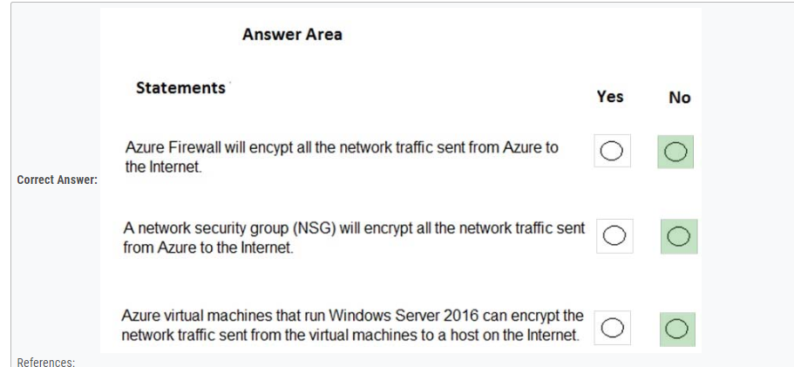

87. Your company has an Azure environment that contains resources in several regions.  
A company policy states that administrators must only be allowed to create additional Azure resources in a region in the country where their office is located.  
You need to create the Azure resource that must be used to meet the policy requirement.  
What should you create?

* A. a read-only lock
* B. an Azure policy
* C. a management group
* D. a reservation

88. This question requires that you evaluate the underlined text to determine if it is correct.  
Authorization is the process of verifying a user's credentials.  
Instructions: Review the underlined text. If it makes the statement correct, select "No change is needed". If the statement is incorrect, select the answer choice that makes the statement correct.

* A. No change is needed
* B. Authentication
* C. Federation
* D. Ticketing

89. You need to configure an Azure solution that meets the following requirements:  
✑ Secures websites from attacks  
✑ Generates reports that contain details of attempted attacks  
What should you include in the solution?

* A. Azure Firewall
* B. a network security group (NSG)
* C. Azure Information Protection
* D. DDoS protection

90. You plan to implement several security services for an Azure environment. You need to identify which Azure services must be used to meet the following security requirements:  
✑ Monitor threats by using sensors  
✑ Enforce azure Multi-Factor Authentication (MFA) based on a condition  
Which Azure service should you identify for each requirement? To answer, select the appropriate option in the answer area.  
NOTE: Each correct selection is worth one point.

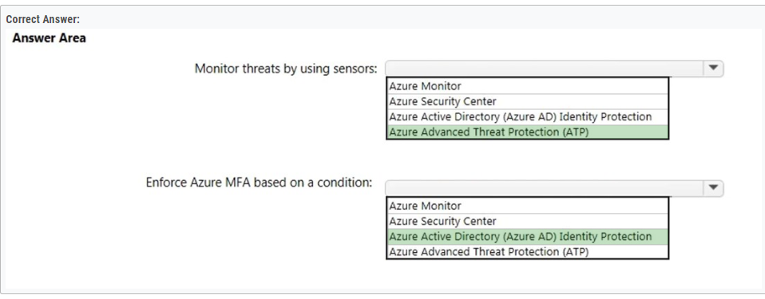

91. 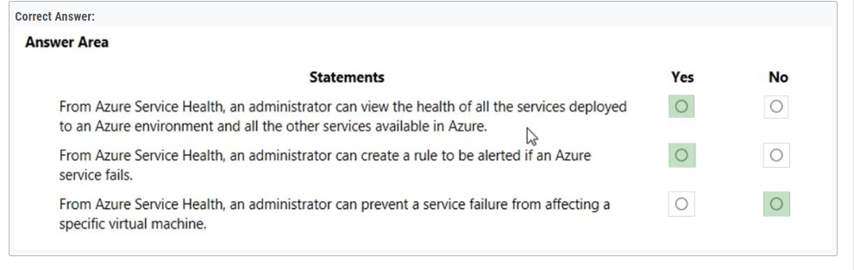

92. Your company plans to migrate all on-premises data to Azure. You need to identify whether Azure complies with the company's regional requirements.  
What should you use?

* A. the Knowledge Center
* B. Azure Marketplace
* C. the Azure portal
* D. the Trust Center

93. This question requires that you evaluate the underlined text to determine if it is correct.  
Azure Key Vault is used to store secrets for Azure Active Directory (Azure AD) user accounts.  
Instructions: Review the underlined text. If it makes the statement correct, select "No change is needed". If the statement is incorrect, select the answer choice that makes the statement correct.

* A. No change is needed
* B. Azure Active Directory (Azure AD) administrative accounts
* C. Personally Identifiable Information (PII)
* D. server applications

94. 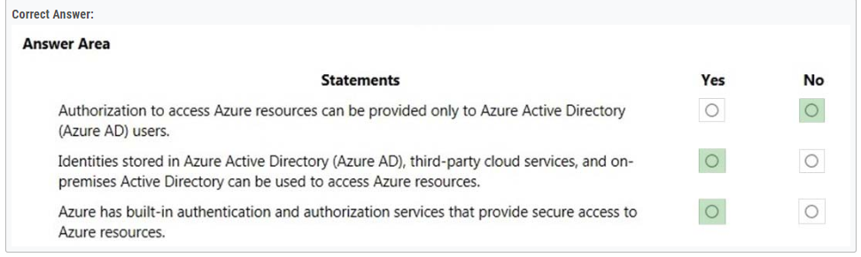

95. Your company plans to automate the deployment of servers to Azure.  
Your manager is concerned that you may expose administrative credentials during the deployment.  
You need to recommend an Azure solution that encrypts the administrative credentials during the deployment.  
What should you include in the recommendation?

* A. Azure Key Vault
* B. Azure Information Protection
* C. Azure Security Center
* D. Azure Multi-Factor Authentication (MFA)

96. ou plan to deploy several Azure virtual machines.  
You need to control the ports that devices on the Internet can use to access the virtual machines.  
What should you use?

* A. a network security group (NSG)
* B. an Azure Active Directory (Azure AD) role
* C. an Azure Active Directory group
* D. an Azure key vault

97. This question requires that you evaluate the underlined text to determine if it is correct.  
You have several virtual machines in an Azure subscription. You create a new subscription. The virtual machines cannot be moved to the new subscription.  
Instructions: Review the underlined text. If it makes the statement correct, select "No change is needed". If the statement is incorrect, select the answer choice that makes the statement correct.

* A. No change is needed
* B. The virtual machines can be moved to the new subscription
* C. The virtual machines can be moved to the new subscription only if they are all in the same resource group
* D. The virtual machines can be moved to the new subscription only if they run Windows Server 2016.

98. You attempt to create several managed Microsoft SQL Server instances in an Azure environment and receive a message that you must increase your Azure subscription limits.  
What should you do to increase the limits?

* A. Create a service health alert
* B. Upgrade your support plan
* C. Modify an Azure policy
* D. Create a new support request

99. 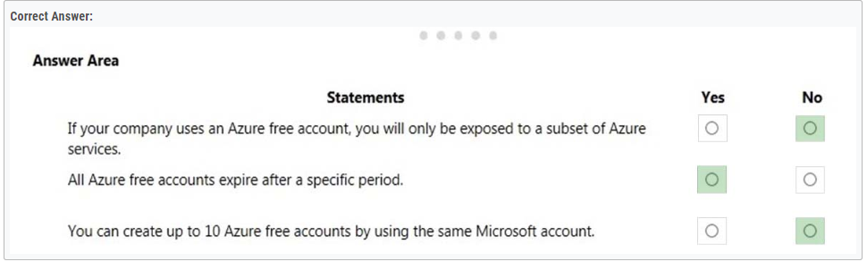

100. 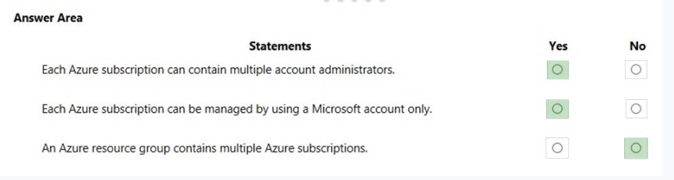

101. Your company has 10 offices. You plan to generate several billing reports from the Azure portal. Each report will contain the Azure resource utilization of each office.  
Which Azure Resource Manager feature should you use before you generate the reports?

* A. tags
* B. templates
* C. locks
* D. policies

102. 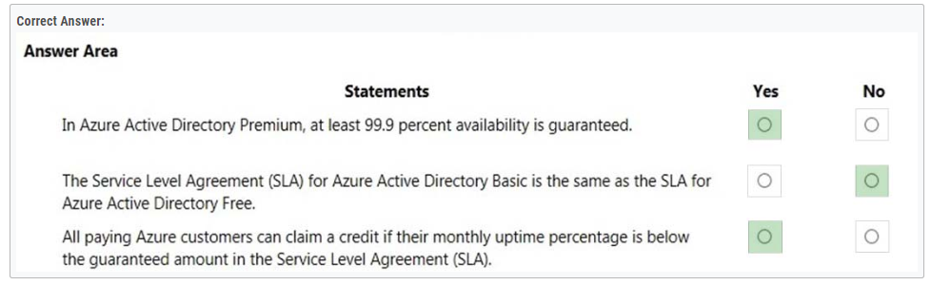

103. This question requires that you evaluate the underlined text to determine if it is correct.  
You deploy an Azure resource. The resource becomes unavailable for an extended period due to a service outage. Microsoft will automatically refund your bank account.  
Instructions: Review the underlined text. If it makes the statement correct, select "No change is needed". If the statement is incorrect, select the answer choice that makes the statement correct.

* A. No change is needed.
* B. automatically migrate the resource to another subscription
* C. automatically credit your account
* D. send you a coupon code that you can redeem for Azure credits

104. 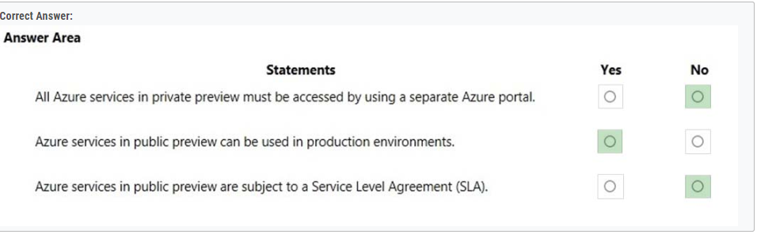

105. 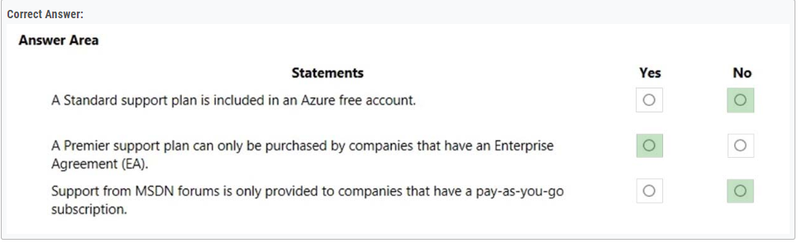

106. Your company plans to migrate to Azure. The company has several departments. All the Azure resources used by each department will be managed by a department administrator.  
You need to recommend an Azure deployment that provides the ability to segment Azure for the departments. The solution must minimize administrative effort.  
What should you include in the recommendation?

* A. multiple subscriptions
* B. multiple Azure Active Directory (Azure AD) directories
* C. multiple regions
* D. multiple resource groups

107. Note: This question is part of a series of questions that present the same scenario. Each question in the series contains a unique solution that might meet the stated goals. Some question sets might have more than one correct solution, while others might not have a correct solution.  
After you answer a question in this section, you will NOT be able to return to it. As a result, these questions will not appear in the review screen.  
Your company has an Azure subscription that contains the following unused resources:  
✑ 20 user accounts in Azure Active Directory (Azure AD)  
✑ Five groups in Azure AD  
✑ 10 public IP addresses  
✑ 10 network interfaces  
You need to reduce the Azure costs for the company.  
Solution: You remove the unused public IP addresses.  
Does this meet the goal?

* A. Yes
* B. No

108. 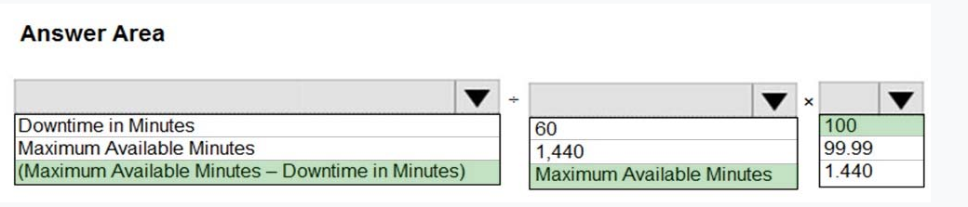

109. 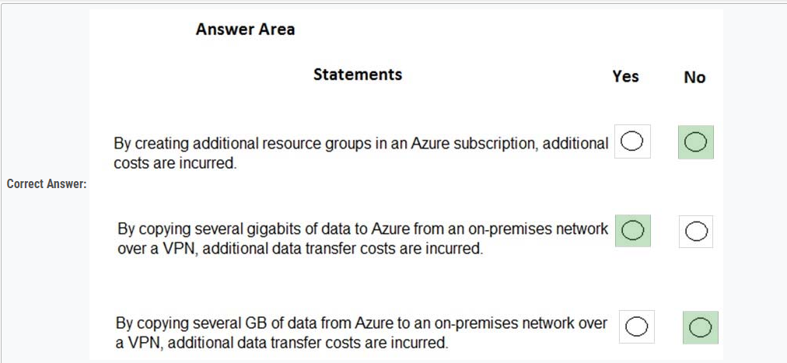

110. This question requires that you evaluate the underlined text to determine if it is correct.  
A support plan solution that gives you best practice information, health status and notifications, and 24/7 access to billing information at the lowest possible cost is a Standard support plan.  
Instructions: Review the underlined text. If it makes the statement correct, select "No change is needed". If the statement is incorrect, select the answer choice that makes the statement correct.

* A. No change is needed
* B. Developer
* C. Basic
* D. Premier

111. Note: This question is part of a series of questions that present the same scenario. Each question in the series contains a unique solution that might meet the stated goals. Some question sets might have more than one correct solution, while others might not have a correct solution.  
After you answer a question in this section, you will NOT be able to return to it. As a result, these questions will not appear in the review screen.  
You plan to deploy several Azure virtual machines.  
You need to ensure that the services running on the virtual machines are available if a single data center fails.  
Solution: You deploy the virtual machines to two or more resource groups.  
Does this meet the goal?

* A. Yes
* B. No

112. In which Azure support plans can you open a new support request?

* A. Premier and Professional Direct only
* B. Premier, Professional Direct, and Standard only
* C. Premier, Professional Direct, Standard, and Developer only
* D. Premier, Professional Direct, Standard, Developer, and Basic

113. his question requires that you evaluate the underlined text to determine if it is correct.  
You can create an Azure support request from support.microsoft.com.  
Instructions: Review the underlined text. If it makes the statement correct, select "No change is needed." If the statement is incorrect, select the answer choice that makes the statement correct.

* A. No change is needed.
* B. the Azure portal
* C. the Knowledge Center
* D. the Security & Compliance admin center

114. Note: This question is part of a series of questions that present the same scenario. Each question in the series contains a unique solution that might meet the stated goals. Some question sets might have more than one correct solution, while others might not have a correct solution.  
After you answer a question in this section, you will NOT be able to return to it. As a result, these questions will not appear in the review screen.  
Your company has an Azure subscription that contains the following unused resources:  
✑ 20 user accounts in Azure Active Directory (Azure AD)  
✑ Five groups in Azure AD  
✑ 10 public IP addresses  
✑ 10 network interfaces  
You need to reduce the Azure costs for the company.  
Solution: You remove the unused groups.  
Does this meet the goal?

* A. Yes
* B. No

115. What is guaranteed in an Azure Service Level Agreement (SLA)?

* A. uptime
* B. feature availability
* C. bandwidth
* D. performance

116. This question requires that you evaluate the underlined text to determine if it is correct.  
An Azure service is available to all Azure customers when it is in public preview.  
Instructions: Review the underlined text. If it makes the statement correct, select "No change is needed". If the statement is incorrect, select the answer choice that makes the statement correct.

* A. No change is needed.
* B. private preview
* C. development
* D. an Enterprise Agreement (EA) subscription

117. Note: This question is part of a series of questions that present the same scenario. Each question in the series contains a unique solution that might meet the stated goals. Some question sets might have more than one correct solution, while others might not have a correct solution.  
After you answer a question in this section, you will NOT be able to return to it. As a result, these questions will not appear in the review screen.  
Your company plans to purchase Azure.  
The company's support policy states that the Azure environment must provide an option to access support engineers by phone or email.  
You need to recommend which support plan meets the support policy requirement.  
Solution: Recommend a Basic support plan.  
Does this meet the goal?

* A. Yes
* B. No https://azure.microsoft.com/en-gb/support/plans/

118. Note: This question is part of a series of questions that present the same scenario. Each question in the series contains a unique solution that might meet the stated goals. Some question sets might have more than one correct solution, while others might not have a correct solution.  
After you answer a question in this section, you will NOT be able to return to it. As a result, these questions will not appear in the review screen.  
Your company plans to purchase Azure.  
The company's support policy states that the Azure environment must provide an option to access support engineers by phone or email.  
You need to recommend which support plan meets the support policy requirement.  
Solution: Recommend a Standard support plan.  
Does this meet the goal?

* A. Yes
* B. No

119. Note: This question is part of a series of questions that present the same scenario. Each question in the series contains a unique solution that might meet the stated goals. Some question sets might have more than one correct solution, while others might not have a correct solution.  
After you answer a question in this section, you will NOT be able to return to it. As a result, these questions will not appear in the review screen.  
Your company plans to purchase Azure.  
The company's support policy states that the Azure environment must provide an option to access support engineers by phone or email.  
You need to recommend which support plan meets the support policy requirement.  
Solution: Recommend a Premier support plan.  
Does this meet the goal?

* A. Yes
* B. No

**Correct Answer:** *A*  
The Standard, Professional Direct, and Premier support plans have technical support for engineers via email and phone.

120. Your company plans to request an architectural review of an Azure environment from Microsoft.  
The company currently has a Basic support plan.  
You need to recommend a new support plan for the company. The solution must minimize costs.  
Which support plan should you recommend?

* A. Premier
* B. Developer
* C. Professional Direct
* D. Standard

121. 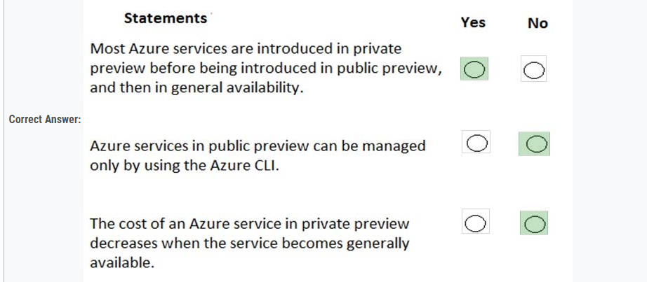

122. What is required to use Azure Cost Management?

* A. a Dev/Test subscription
* B. Software Assurance
* C. an Enterprise Agreement (EA)
* D. a pay-as-you-go subscription

123. This question requires that you evaluate the underlined text to determine if it is correct.  
Your Azure trial account expired last week. You are now unable to create additional Azure Active Directory (Azure AD) user accounts.  
Instructions: Review the underlined text. If it makes the statement correct, select "No change is needed". If the statement is incorrect, select the answer choice that makes the statement correct.

* A. No change is needed
* B. start an existing Azure virtual machine
* C. access your data stored in Azure
* D. access the Azure portal

124. Note: This question is part of a series of questions that present the same scenario. Each question in the series contains a unique solution that might meet the stated goals. Some question sets might have more than one correct solution, while others might not have a correct solution.  
After you answer a question in this section, you will NOT be able to return to it. As a result, these questions will not appear in the review screen.  
Your company plans to purchase Azure.  
The company's support policy states that the Azure environment must provide an option to access support engineers by phone or email.  
You need to recommend which support plan meets the support policy requirement.  
Solution: Recommend a Professional Direct support plan.  
Does this meet the goal?

* A. Yes
* B. No

125. our company has 10 departments.  
The company plans to implement an Azure environment.  
You need to ensure that each department can use a different payment option for the Azure services it consumes.  
What should you create for each department?

* A. a reservation
* B. a subscription
* C. a resource group
* D. a container instance

126. 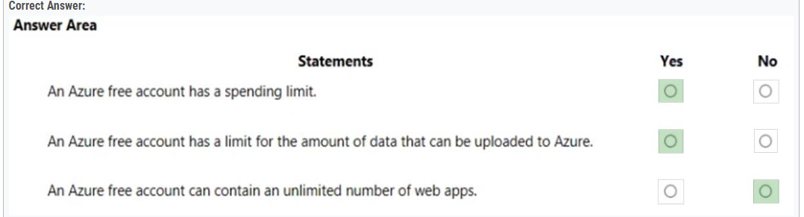

127. 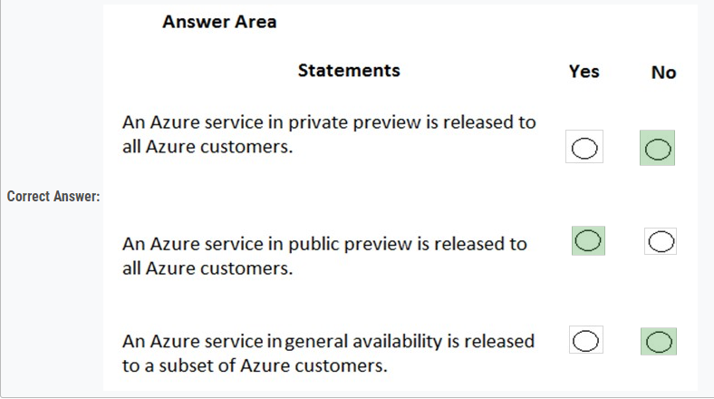

128. 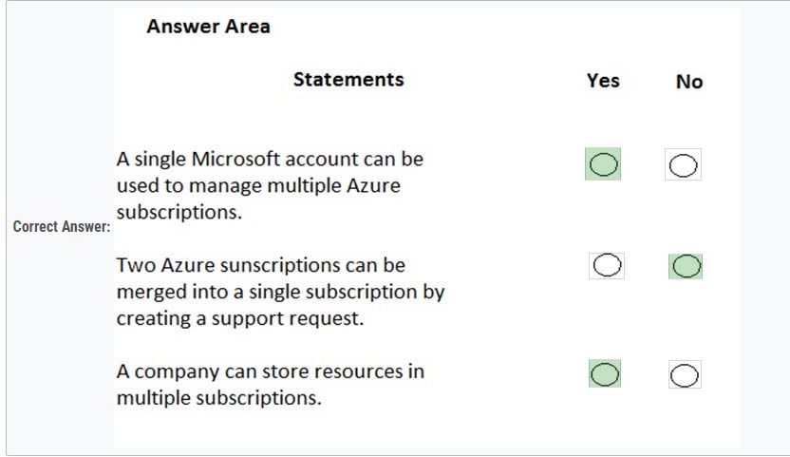

129. 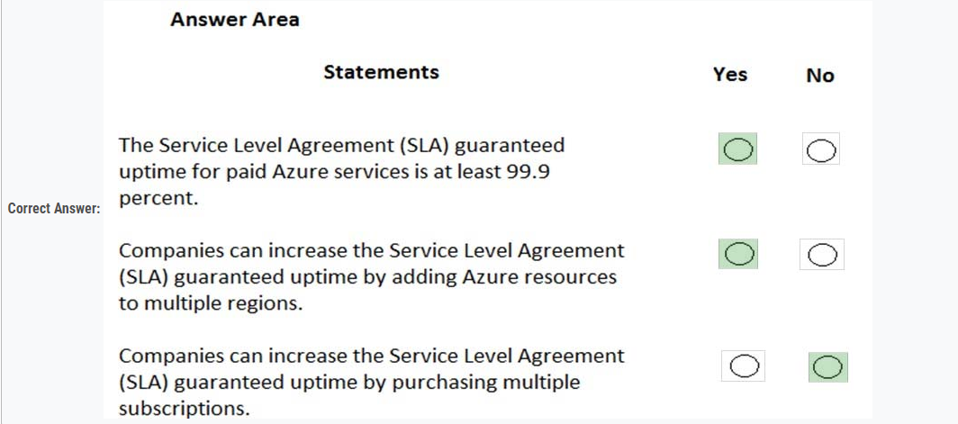

130. 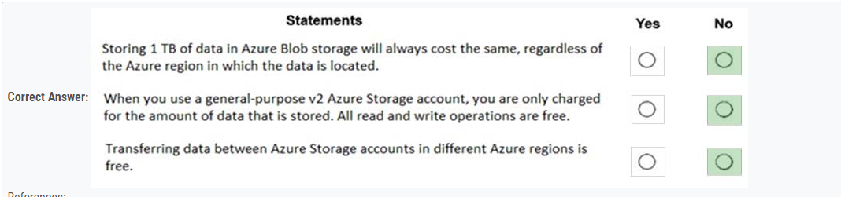

131. You plan to provision Infrastructure as a Service (IaaS) resources in Azure.  
Which resource is an example of IaaS?

* A. an Azure web app
* B. an Azure virtual machine
* C. an Azure logic app
* D. an Azure SQL database

132. A team of developers at your company plans to deploy, and then remove, 50 virtual machines each week. All the virtual machines are configured by using Azure  
Resource Manager templates.  
You need to recommend which Azure service will minimize the administrative effort required to deploy and remove the virtual machines.  
What should you recommend?

* A. Azure Reserved Virtual Machines (VM) Instances
* B. Azure DevTest Labs
* C. Azure virtual machine scale sets
* D. Microsoft Managed Desktop

133. Note: This question is part of a series of questions that present the same scenario. Each question in the series contains a unique solution that might meet the stated goals. Some question sets might have more than one correct solution, while others might not have a correct solution.  
After you answer a question in this section, you will NOT be able to return to it. As a result, these questions will not appear in the review screen.  
You have an Azure subscription named Subscription1. You sign in to the Azure portal and create a resource group named RG1.  
From Azure documentation, you have the following command that creates a virtual machine named VM1. az vm create --resource-group RG1 --name VM1 -- image  
  
UbuntuLTS --generate-ssh-keys -  
You need to create VM1 in Subscription1 by using the command.  
Solution: From the Azure portal, launch Azure Cloud Shell and select PowerShell. Run the command in Cloud Shell.  
Does this meet the goal?

* A. Yes
* B. No

134. This question requires that you evaluate the underlined text to determine if it is correct.  
If Microsoft plans to end support for an Azure service that does NOT have a successor service, Microsoft will provide notification at least 12 months before.  
Instructions: Review the underlined text. If it makes the statement correct, select "No change is needed". If the statement is incorrect, select the answer choice that makes the statement correct.

* A. No change is needed.
* B. 6 months
* C. 90 days
* D. 30 days

135. Your company plans to deploy several custom applications to Azure. The applications will provide invoicing services to the customers of the company. Each application will have several prerequisite applications and services installed.  
You need to recommend a cloud deployment solution for all the applications.  
What should you recommend?

* A. Software as a Service (SaaS)
* B. Platform as a Service (PaaS)
* C. Infrastructure as a Service (laaS)

136. Which service provides serverless computing in Azure?

* A. Azure Virtual Machines
* B. Azure Functions
* C. Azure storage account
* D. Azure Container Instances

137. Which Azure service provides a set of version control tools to manage code?

* A. Azure Repos
* B. Azure DevTest Labs
* C. Azure Storage
* D. Azure Cosmos DB

138. Which service provides network traffic filtering across multiple Azure subscriptions and virtual networks?

* A. Azure Firewall
* B. an application security group
* C. Azure DDoS protection
* D. a network security group (NSG)

139. This question requires that you evaluate the underlined text to determine if it is correct.  
From Azure Cloud Shell, you can track your company's regulatory standards and regulations, such as ISO 27001.  
Instructions: Review the underlined text. If it makes the statement correct, select "No change is needed." If the statement is incorrect, select the answer choice that makes the statement correct.

* A. No change is needed.
* B. the Microsoft Cloud Partner Portal
* C. Compliance Manager
* D. the Trust Center

140. This question requires that you evaluate the underlined text to determine if it is correct.  
The Microsoft Online Services Privacy Statement explains what data Microsoft processes, how Microsoft processes the data, and the purpose of processing the data.  
Instructions: Review the underlined text. If it makes the statement correct, select "No change is needed." If the statement is incorrect, select the answer choice that makes the statement correct.

* A. No change is needed.
* B. Microsoft Online Services Terms
* C. Microsoft Online Service Level Agreement
* D. Online Subscription Agreement for Microsoft Azure

141. Your company plans to migrate to Azure. The company has several departments. All the Azure resources used by each department will be managed by a department administrator.  
What are two possible techniques to segment Azure for the departments? Each correct answer presents a complete solution.  
NOTE: Each correct selection is worth one point.

* A. multiple subscriptions
* B. multiple Azure Active Directory (Azure AD) directories
* C. multiple regions
* D. multiple resource groups

142. Which statement accurately describes the Modern Lifecycle Policy for Azure services?

* A. Microsoft provides mainstream support for a service for five years.
* B. Microsoft provides a minimum of 12 months' notice before ending support for a service.
* C. After a service is made generally available, Microsoft provides support for the service for a minimum of four years.
* D. When a service is retired, you can purchase extended support for the service for up to five years.

143. This question requires that you evaluate the underlined text to determine if it is correct.  
You can use Advisor recommendations in Azure to send email alerts when the cost of the current billing period for an Azure subscription exceeds a specified limit.  
Instructions: Review the underlined text. If it makes the statement correct, select "No change is needed." If the statement is incorrect, select the answer choice that makes the statement correct.

* A. No change is needed.
* B. Access control (IAM)
* C. Budget alerts
* D. Compliance